**Validating multiplex PCR primers for Tanzanian rabies virus genome amplification**

Rabies virus (RABV) RNA samples archived at the Animal & Plant Health Agency (Weybridge, UK) were used to validate primers targeting Tanzanian RABV lineages. A multiplex primer scheme was designed using Primal Scheme <http://primal.zibraproject.org/> with a set of previously published genome sequences.

GenBank accession numbers for reference sequences used for primer design (in order): KR906748.1, KR906747.1, KY210263.1, KY210264.1, KY210227.1, KR906774.1, KR906763.1, KR906742.1,  KR534218.2, KY210305.1.

Primer sequences are listed in GitHub repository <https://github.com/kirstyn/rabies_minion>

Table 1. Rabies virus samples used to test primers for multiplex PCR targeting Tanzanian rabies virus lineages. CT value indicates the cycle threshold value from a real-time PCR assay, depleted column indicates if the sample was treated with DNase I to deplete host genomic DNA

|  |  |  |  |  |  |
| --- | --- | --- | --- | --- | --- |
|  | **Sample ID** | **CT value** | **Depleted?** | **Visible gel band** | **Notes** |
| A | rv3227 | 15 | yes | yes |  |
| B | rv3237 | 24 | yes | no |  |
| C | sub3258 | 27 | yes | yes | 1st result negative, repeated |
| D | rab16024 | 20 | yes | yes |  |
| E | rab16025 | 23 | yes | yes |  |
| F | CVS-11 | 22 | yes | yes | More non-specific bands |
| G | rv2917 | 25 | no | yes |  |
| H | rv2918 | 14 | no | yes | 1st result negative, repeated. Had to use more cDNA to get a positive band |
| I | Peru dog 121-2012 | unknown | no | yes | More non-specific bands |
| J | SD557 | 23 | yes | yes |  |
| K | sub7087 | unknown | yes | yes |  |

**Summary of PCR results**

**Samples A-C (Figure 1)**

- DNase I depleted samples. 7ul of depleted cDNA was used in the PCR reaction.

1. RV3227 (low Ct)
2. RV3237 (medium Ct)
3. RV3258 (high Ct)

PCR cycle:

Step1: 95°C 30 sec

Step 2 35 cycles: 95°C 15 sec; 65°C 15mins*

4°C hold

*Mistake in program, should have been 5mins

- 5μl of PCR products run on 2% agarose gel

Result

* only rv3227, the low CT sample had visible band
* products visible at ~400bp and also larger band ~800bp
* 15mins is too long for annealing/extension! Was meant to be 5mins

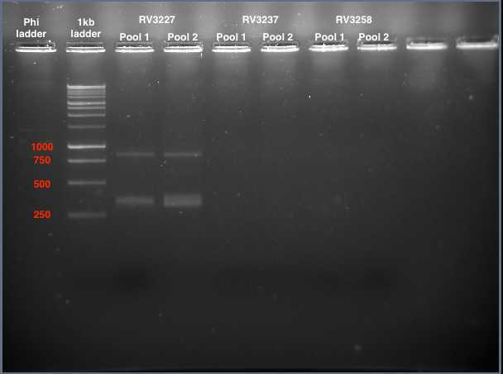

Figure 1. PCR for samples A to C

**Samples D-F (Figure 2)**

1. RAB16025 (CT=20),

2. RAB16024 (CT=23),

3. CVS

Cycle:

Step1: 98°C 30 sec

Step 2 45 cycles: 98°C 15 sec; 65°C 5mins

4°C hold

Result

* all had positive bands (2% agarose gel)
* amplification of larger products and more non-specific bands for CVS and Rab16/024

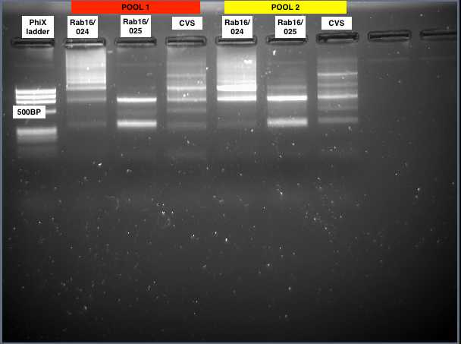

Figure 2. PCR for samples D-F

**Sample G-I and repeat of C (Figure 3)**

1. RV2917: low CT, neat RNA
2. RV2918: medium CT, neat RNA
3. RV3258: high CT, depleted RNA (repeat)
4. ID121-2012 Dog (Peru dog sample)

PCR cycle:

Step1: 98°C 30 sec

Step 2 45 cycles: 98°C 15 sec; 65°C 5mins

4°C hold

Result

* Tanzania RABV samples rv2917 (neat, ct 25) and rv3258 (depleted, ct 27) have bands. Rv3258 did not amplify in previous attempt
* Peru dog sample amplified

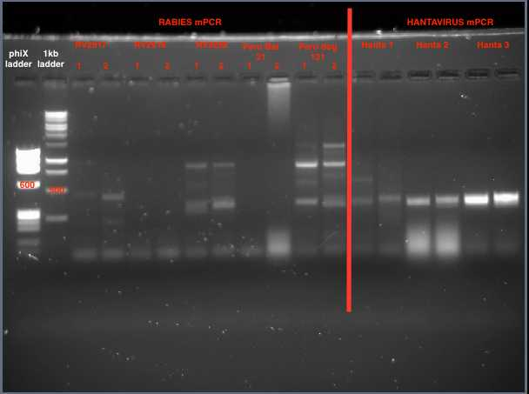

Not applicable

2.RV2918

3.RV3258

1.RV2917

4. Peru dog

Figure 3. PCR for samples G-I and repeat of C

**Sample J (Figure 4)**

1. SD557

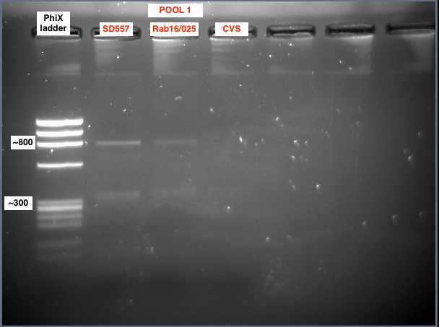- using 5ul of depleted RNA

Figure 4. PCR for sample J

PCR cycle:

50°C for 30 min,

95°C 15mins

94°C 30 sec

65°C 5min x45 cycles

4°C ∞

**C & H repeats (Figure 5)**

1. **RV2918**
2. **Sub3258**

- PCR repeated using larger volumes of cDNA in reaction (1.5ul to 3ul)

- Faint band observed for RV2918 at expected size of ~400bp at highest volume (3ul)

- SUB3258 worked at all volumes (except pool 2 at 2μl but probably just loading error)

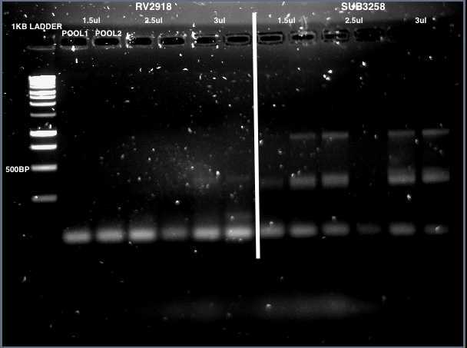

Figure 5. PCR for repeats of samples C and H

**Sample K (Figure 6)**

1. SUB7087

Wells: 1. Ladder, 2. Sub7087, pool 1 mini, 3. Pool2 mini, 4. Pool1 standard thermocycler, 5. Pool2 standard

Result: Amplification of a >1kb product (top band) and ~800bp product. Also very faint 400bp band (hard to see in gel picture)

Figure 6. PCR for sample K

